Specifications of the device I would like to buy:

CPU “central processing unit”:
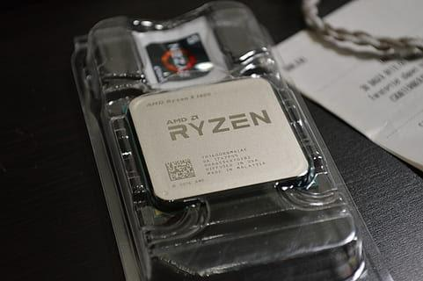
As we know the processors are the brains of the computers that Every action, operation and instruction that the computer performs passes through it … it ensure that all tasks are performed correctly and efficiently.
For CPU I will choose AMD Ryzen 7 7800X3D. It is Octa-core that contains 8 processors with 4.2 GHz and it can perform approximately close to 8 billion instructions per second. It is very fast and it is very good for games !

Motherboard:
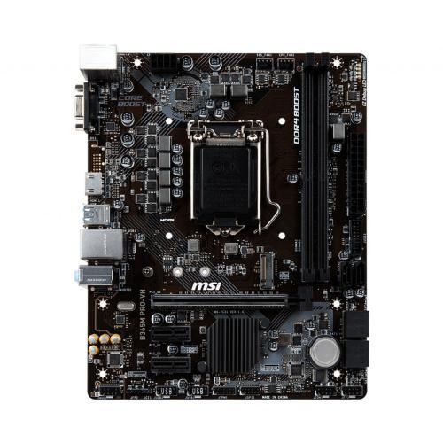
The motherboard is the primary circuit board that allow all components to talk to each others in the computer… it make all the internal (as CPU and RAM) and externals (as USB AND HDMI)components are connected. It is sometimes referred to as the main circuit board or the logic board. So I will choose MSI PRO B650M-E Micro ATX AM5 Motherboard . I had chosen it because it is Suitable for the CPU.

Short term memory “RAM”:
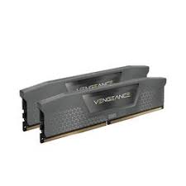
RAM ‘‘Random Access Memory ’’ is also called ‘‘ main memory ’’ it is memory that is stored in the computer while it is running it is fast at retrieving the informations that is needed while computer is running like files or tabs that we open on the desktop but it loses all these informations when the computer shuts downs here , i chose Corsair Vengeance 32 GB (2 x 16 GB) DDR5-6000 CL30 Memory
For memory . It is 32 gigabytes and this is good and fast it will .

Long term storage ‘‘SSD’’, “HDD” :
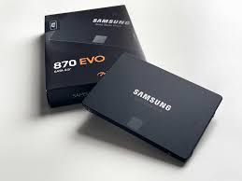
Long term storage means all the data that has been saved in the computer it does not lose even if the computer is shut down it can be files of a user or data associated by the device … I know that it is preferred to use HDD with an SSD to have more storage space (Regardless of the slowness of the HDD) … but I liked to choose SSD with high performance and large amount of storage .I choose Samsung 870 EVO
It is a really fast SSD … its 1 TB! I think it is amazing choice.

Graphics Cards Unit /Graphic card “GPU”:
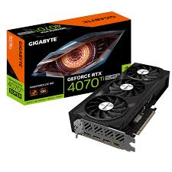
It is used for gaming , video editing and everything associated with image intensive activities; typically they have their own graphics processing unit that performs graphical - based operations … It also refers to video cards . it helps in taking some loads of the main CPU .
Here I will choose the Gigabyte WINDFORCE OC GeForce RTX 4070 Ti SUPER 16 GB Video Card. its graphic ram size is 16 GB.

